**Basic Linux Commands Assignment**

**Assignment – 1**

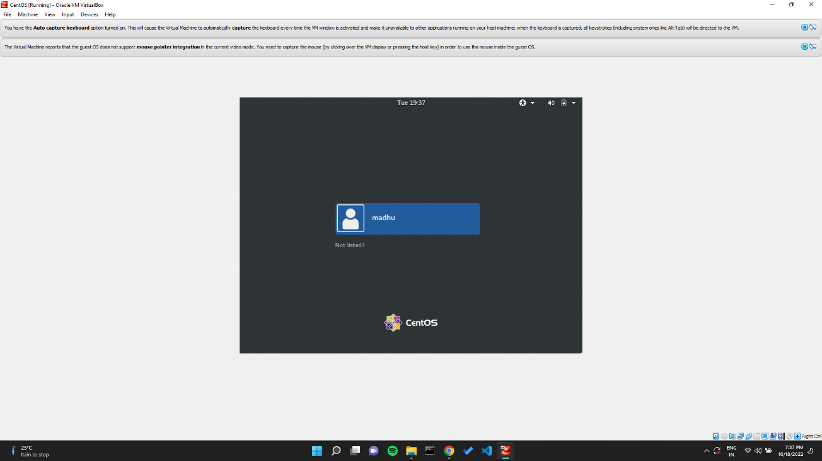

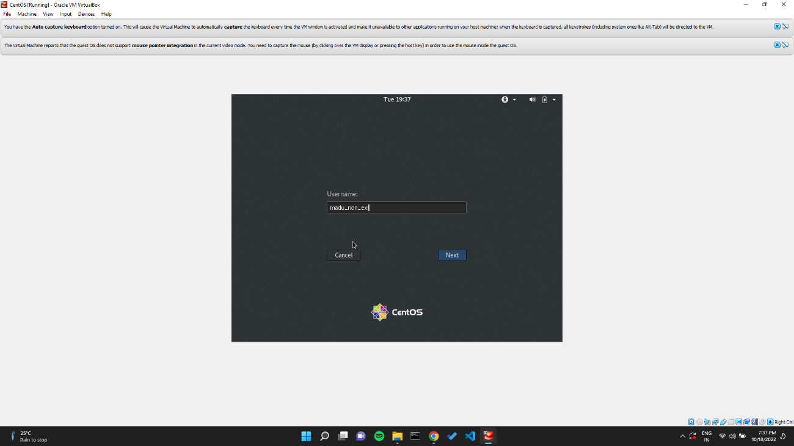

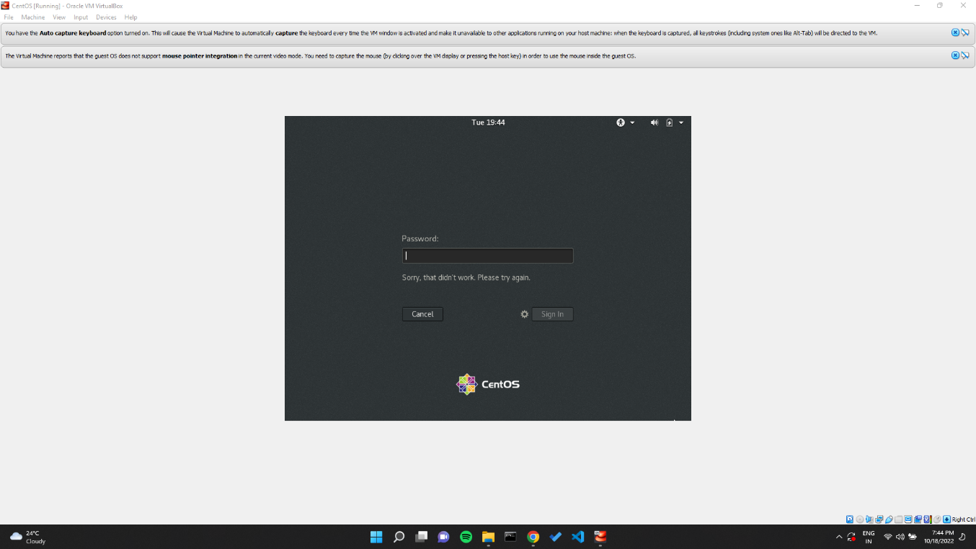

Here tried to login with credentials that were not pre-defined in the system, used a non-existent username and password. Login wasn’t allowed as these users don’t exist in the system.

Error thrown the system – Sorry, this didn’t work. Please try again.

**Assignment – 2**

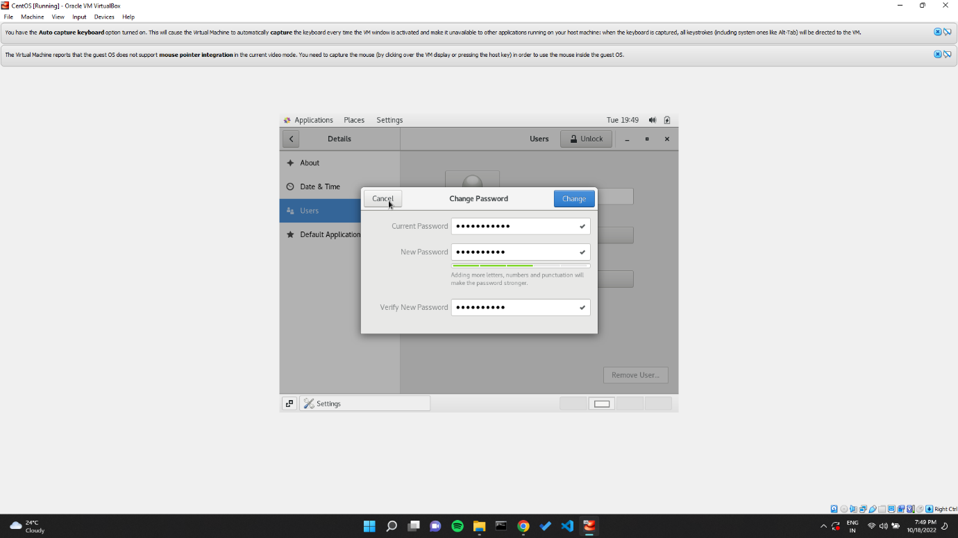

Here the password was changed to **IneuR0n#42.** As it a strong password containing upper case, lower case, numbers & special characters. It accepts the password and reset occurs.

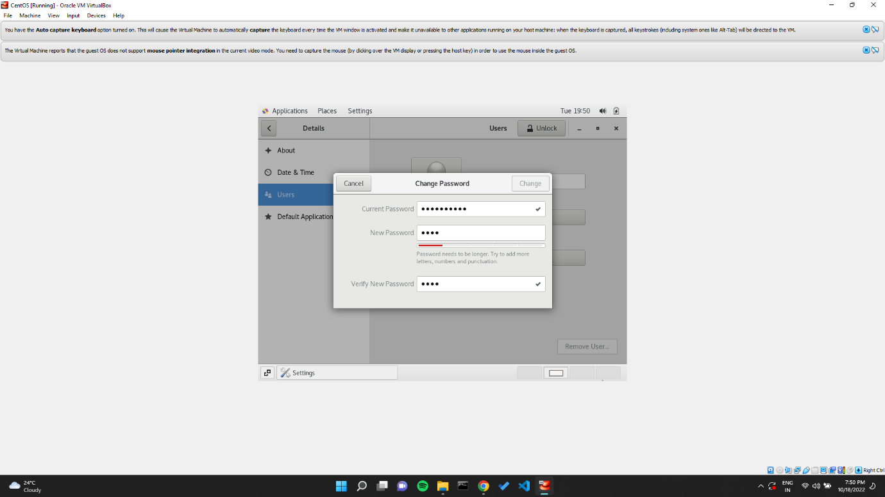

Here the password was changed to **1234.** As it a weak password as it contains just numbers & the length is too small. It does not accept the password and reset does not occur.

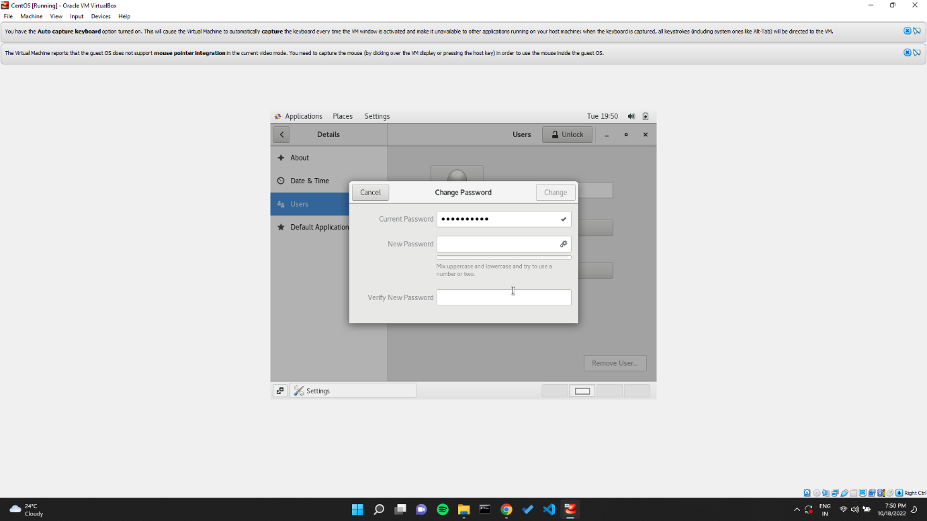

Here the password was changed to **null.** As it a weak password and does not contain anything. It does not accept the password and reset does not occur.

**Assignment – 3**

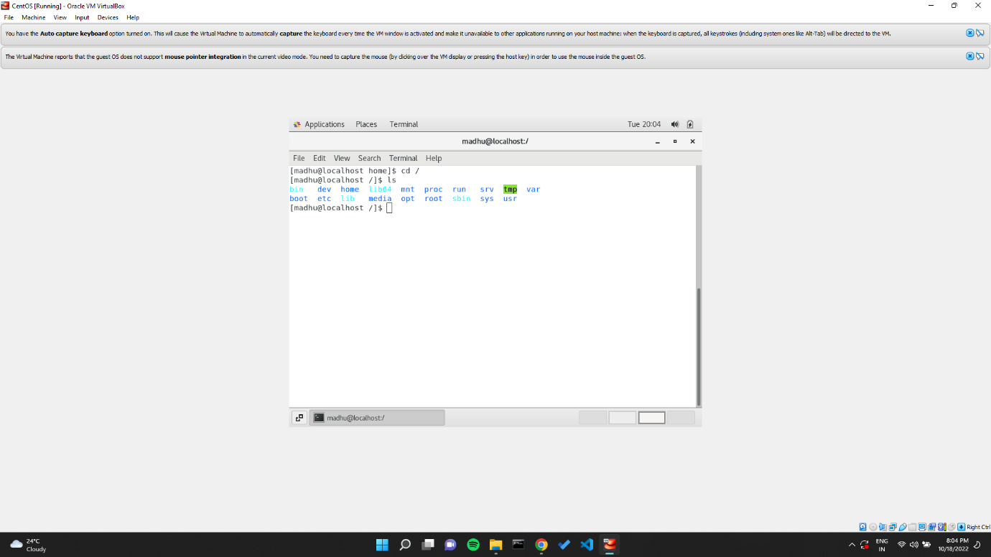

Upon executing the command cd / followed up ls we obtain the list of folders in root.

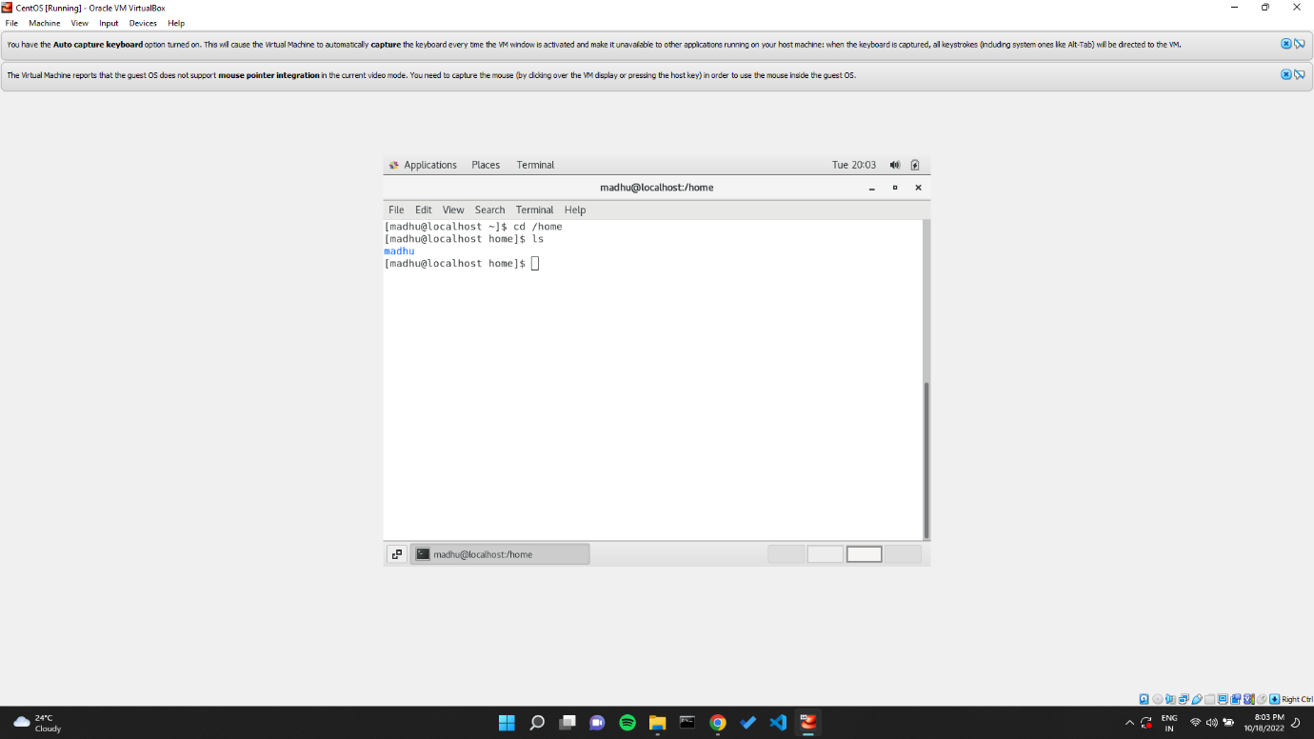

Upon executing the command cd /home followed up ls we obtain user folder setup during installation.

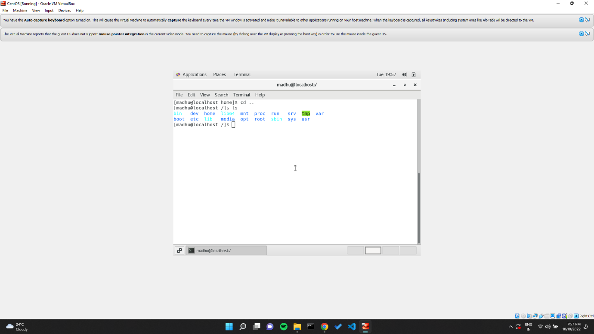

Upon executing the command cd .. , we go behind a folder. One step. The contents in that directory is displayed upon execution of ls.

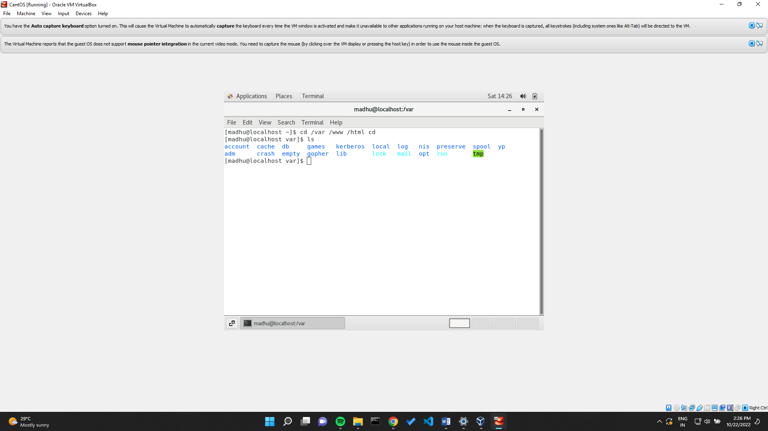

Upon executing the command cd /var/www/html cd, we go var folder and into www and html folder. It contains web dependencies.

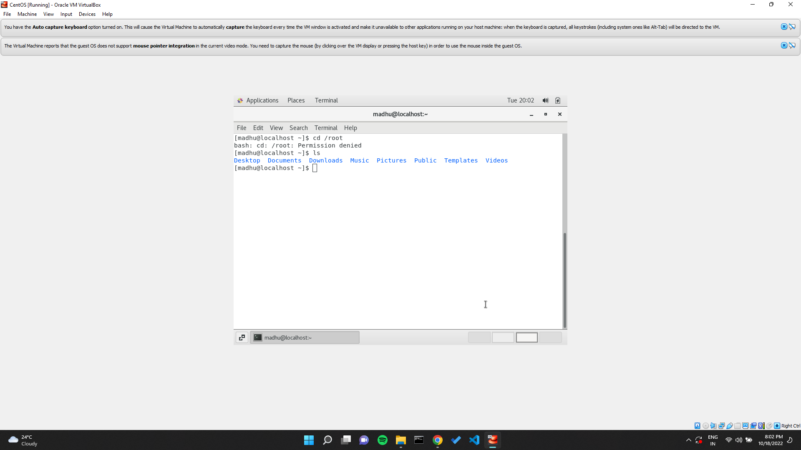

Upon executing the command cd /root , since no root access is provided permission will be denied to access the folder. ls just returns home location folders.

**Assignment – 4**

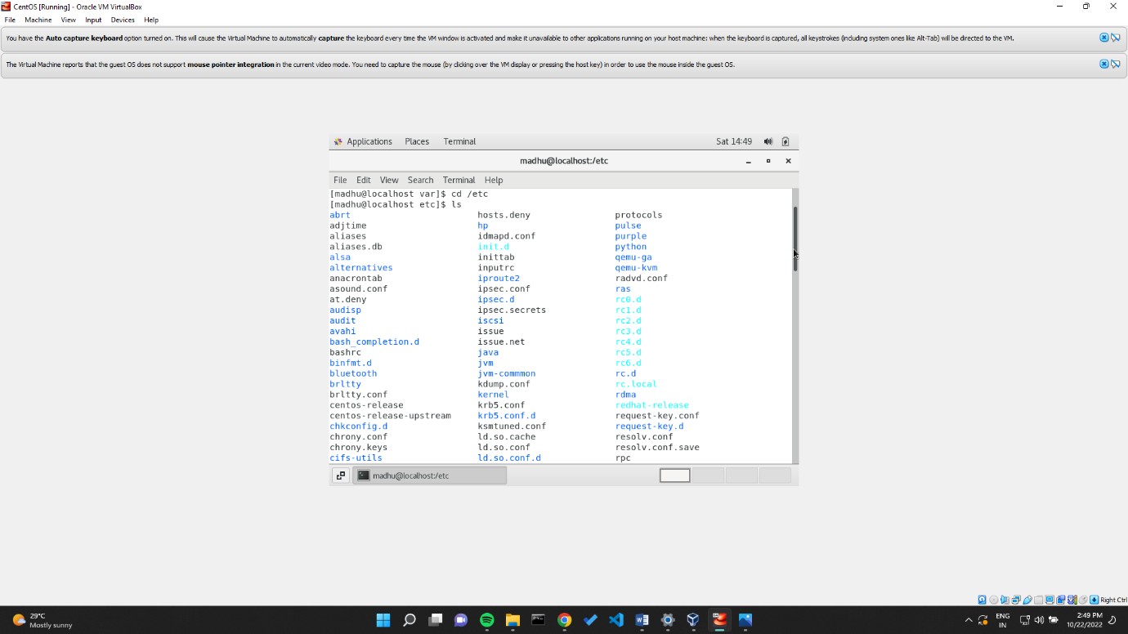

Upon execution of cd /etc followed by ls, we obtain system dependencies like Bluetooth.

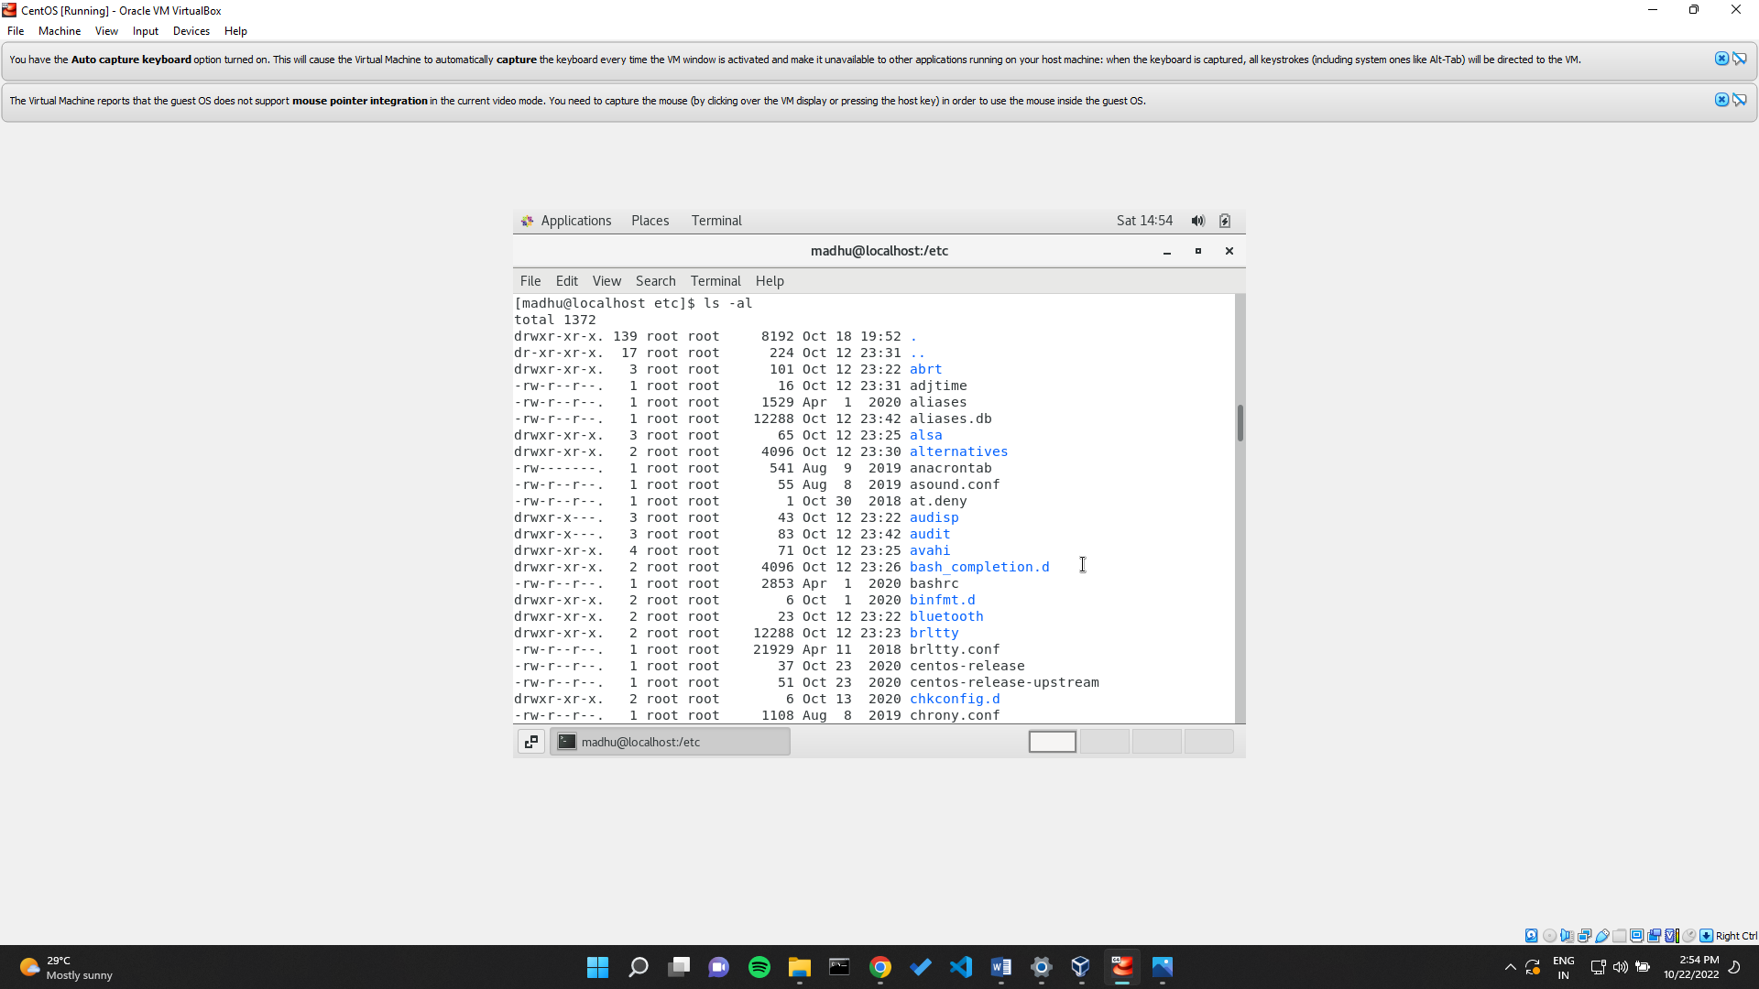

Upon execution we obtain the permissions set for all items in etc directory with date.

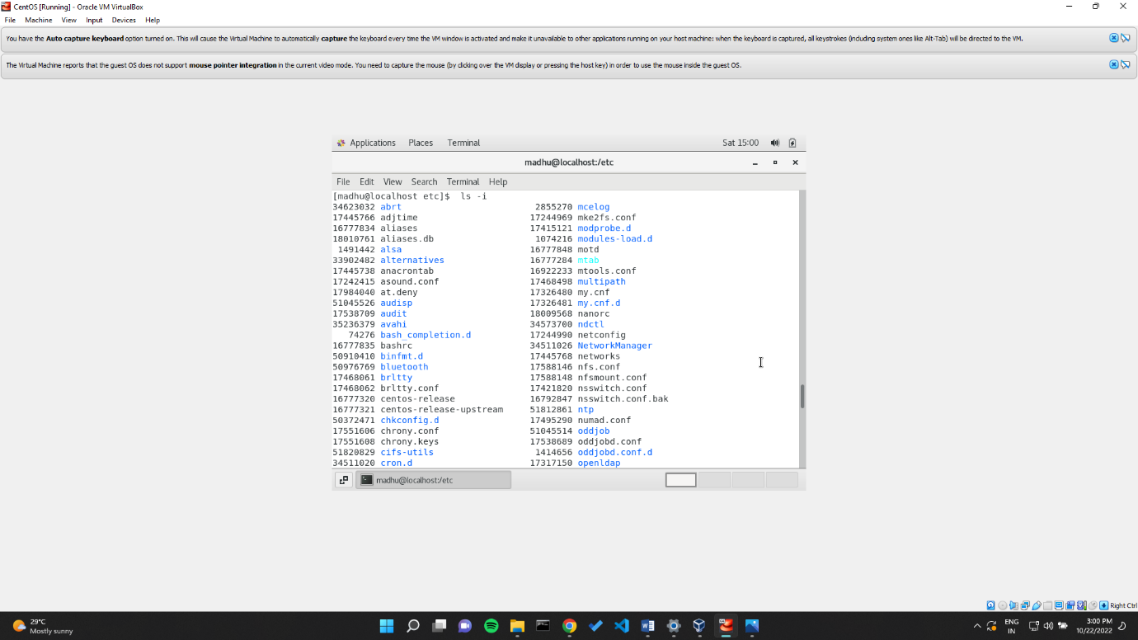

Upon execution we obtain the index numbers of items present in it.

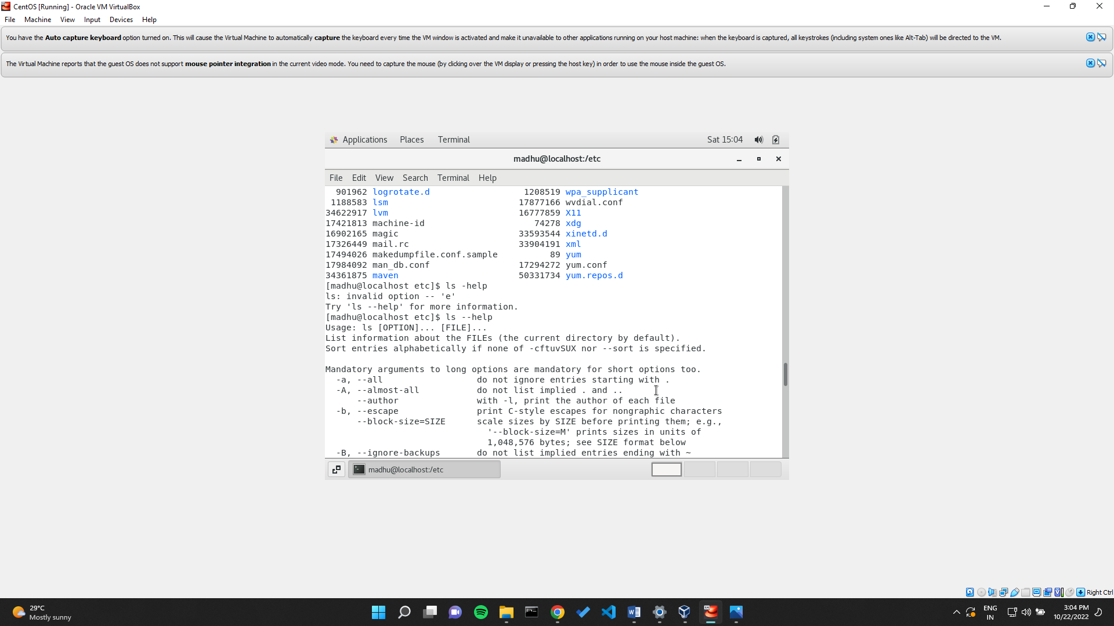

Upon execution we obtain an error, ls – help command is available.

**Assignment – 5**

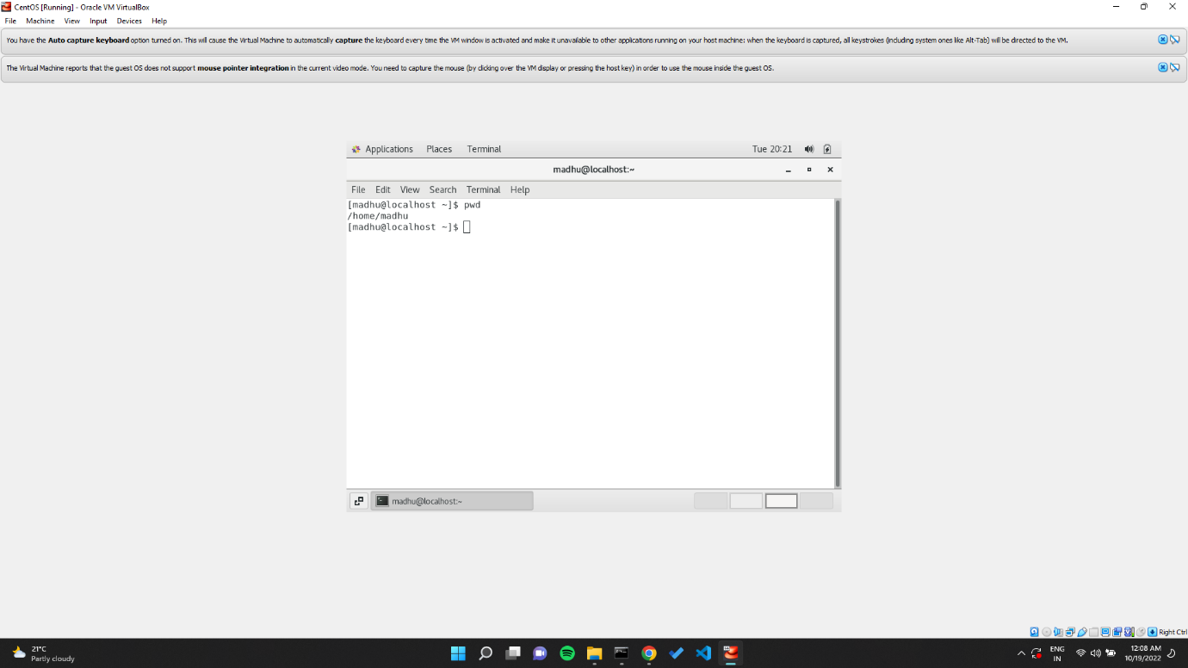

Upon execution we obtain the present working directory that is home and user folder.

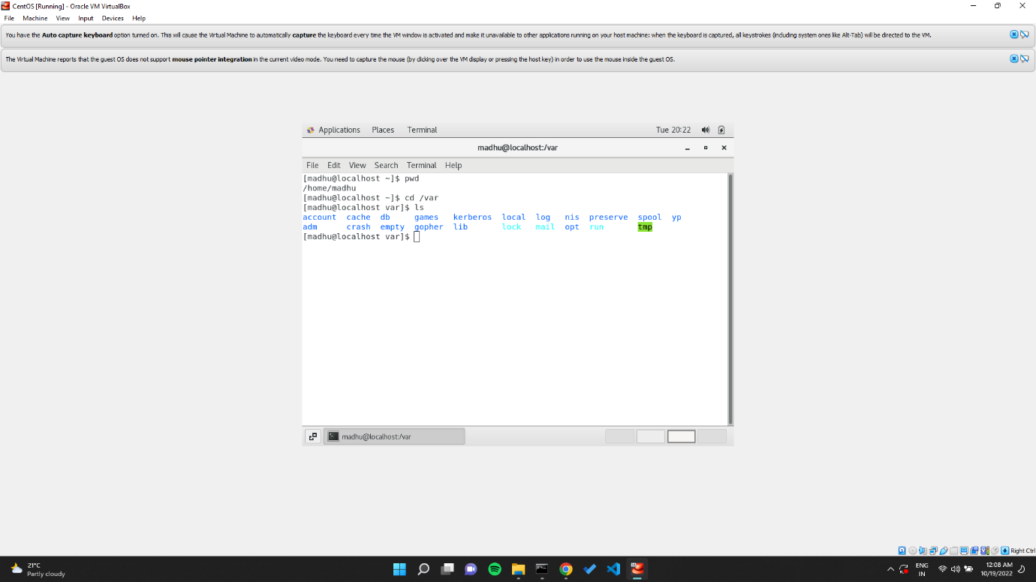

Upon execution we head into the var folder and ls displays all the items in that directory.